ASSIGNMENT 5

🠶Q1 wap to  initialize  
string by assigning value in program  and display it

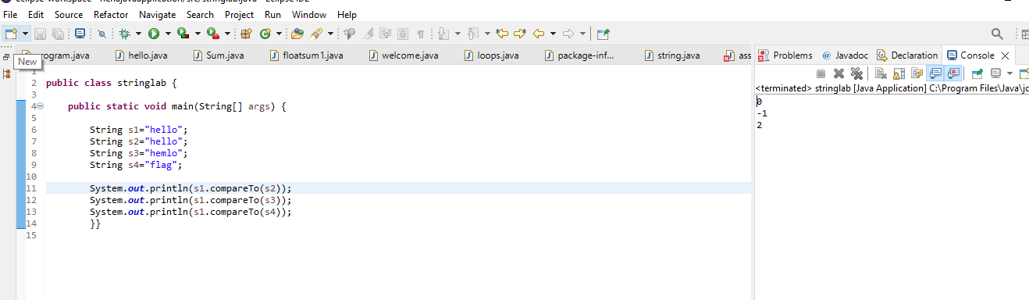

🠶Q 2 wap to ask two string  
values from user and check if they are equal or not

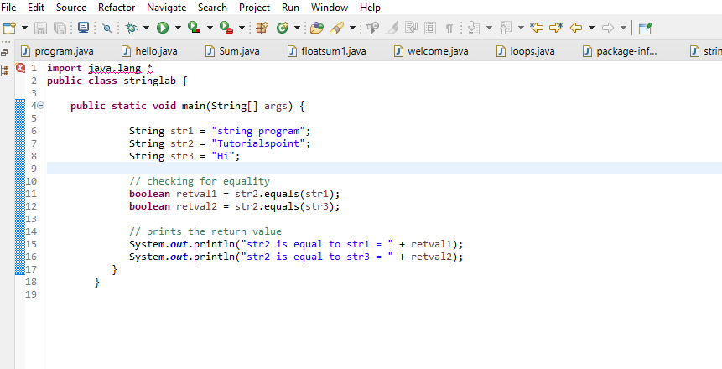

🠶Q 3 wap to compare two  
strings

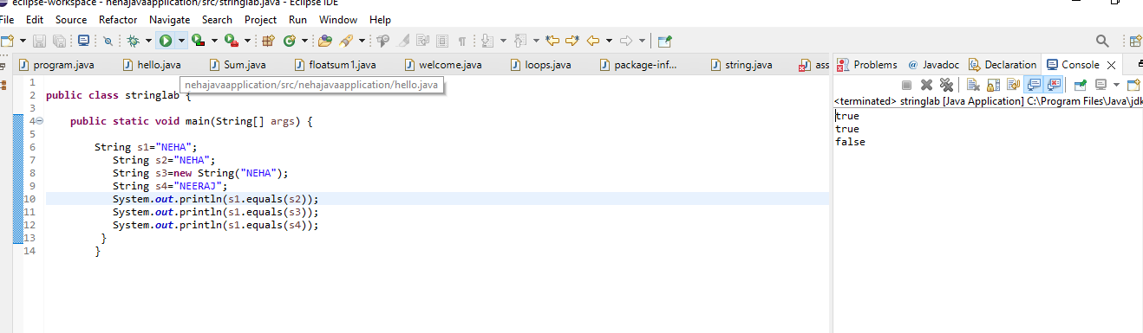

🠶Q 4 wap to print string  
character by character

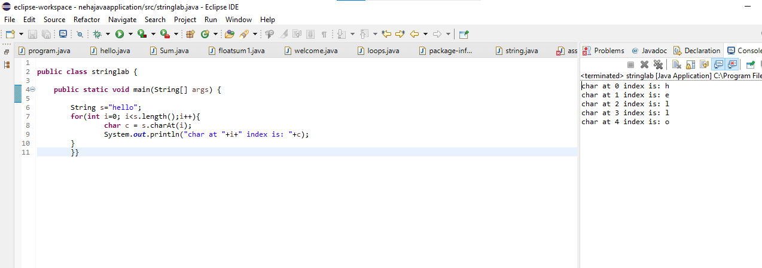  
🠶Q 5 wap to check if string is  
palindrome or not

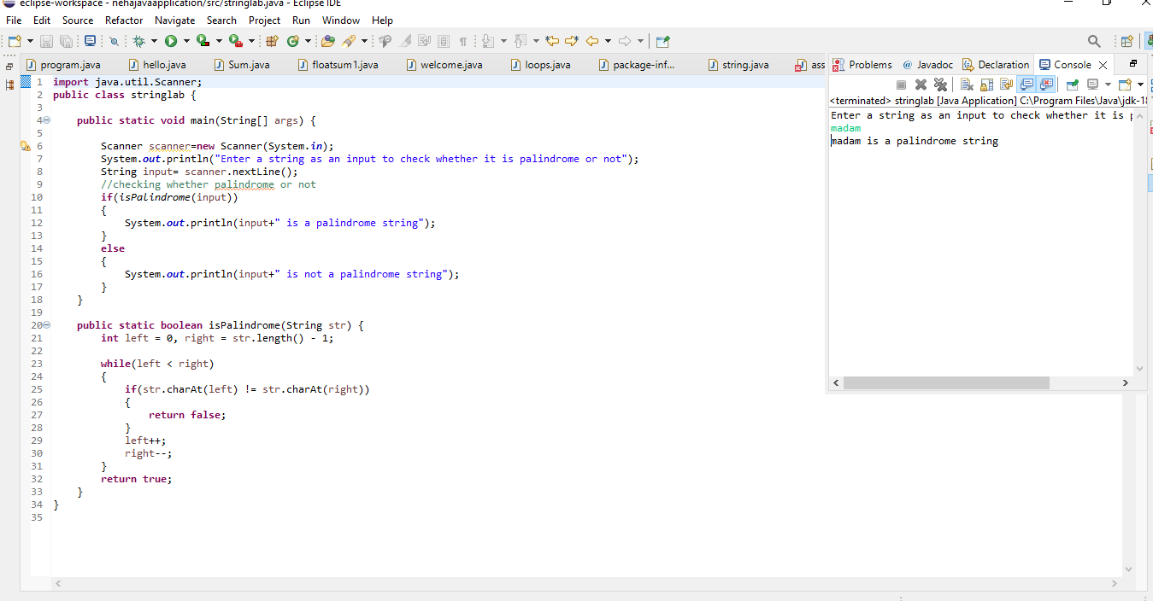

🠶Q 6 wap to count number of  
vowels and consonants in string

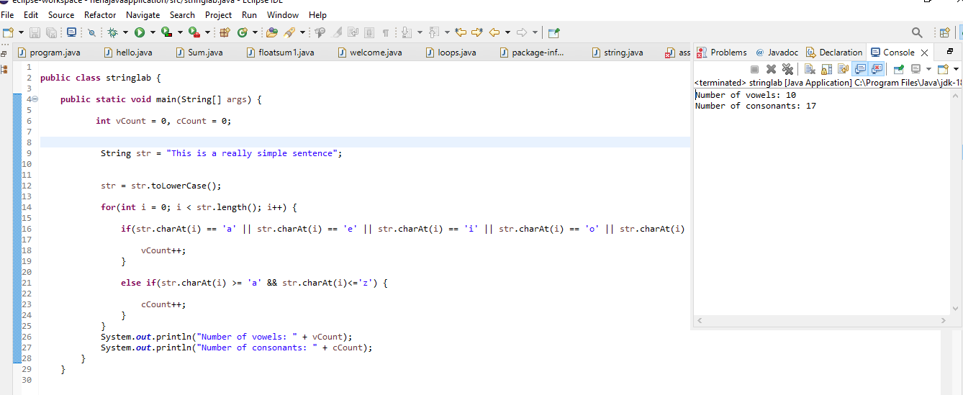

🠶Q 7 wap to count number of  
words in given string

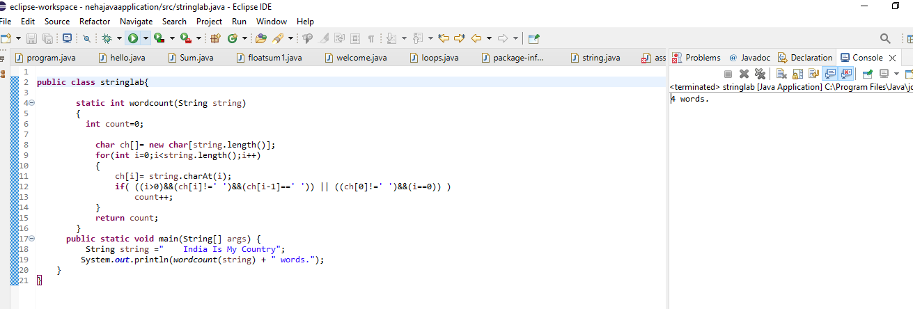

Q 8wap to reverse word in given string

